Final Report:
2019 Looking After Each Other Gathering

May 29 & 30, 2019

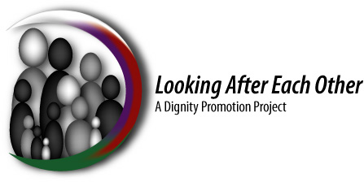

Background
2019 marked the first year that the Looking After Each Other (LAEO) Gathering was held outside of the Winnipeg area.
Based on feedback from discussions at the 2018 LAEO Gathering, it was decided that future Gatherings should be hosted by communities outside of the Winnipeg area to include more rural participation in LAEO Gatherings and to begin promoting dignity for those impacted by FASD in more communities throughout Manitoba.
Members of the South Parkland FASD Coalition and the Brandon and Area FASD Coalition agreed to co-host the 2019 Gathering in their region and they invited Indigenous Elders and leaders from southwestern Manitoba to be part of the LAEO Gathering planning committee.
On May 29th and 30th, the 2019 LAEO Gathering took place at Camp Wannakumbac, located outside of Riding Mountain National Park on the shores of Clear Lake, to include more participation from people within Southwestern Manitoba. The Gathering also brought together FASD coalition members, FASD service providers, program participants, and Elders and Indigenous leaders from across Manitoba. The focus for this year was to build stronger connections with people in attendance and to share information about FASD and the different ways in which we all offer support to people impacted by FASD.
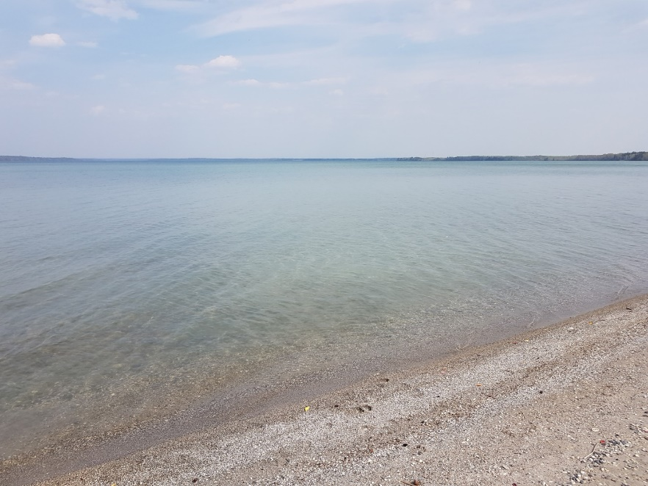
For this year, Gathering participants were encouraged to stay at Camp Wannakumbac in order to connected with the land throughout the entire event. People had the option to stay in one of the cabins at the camp or to bring their own tent.
Many of the gathering participants arrived at the camp the night before on May 28th. Several people took the opportunity to be outside on a warm day and walked down to the shoreline to enjoy the view of Clear Lake. People also had the chance to connect with one another in the evening during dinner.
May 29 – Day 1 of the LAEO Gathering
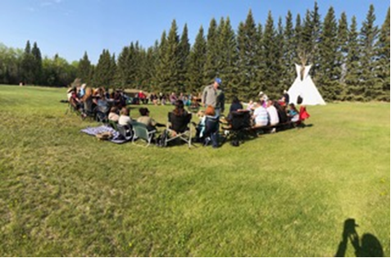
Day one of the Gathering took place outside on the grounds of Camp Wannakumbac. A sacred fire was lit early in the morning, which burned throughout the entire event. Everyone arrived before breakfast and gathered around the sacred fire to participate in a Pipe Ceremony to begin the Gathering.
Pipe Ceremony
Several Elders brought their bundles to the Gathering to participate in a Pipe Ceremony led by Elder Stella Blackbird and Elder Audrey Bone from Keeseekoowenin Ojibway First Nation. Stella and Audrey welcomed everyone to their community and then performed a water blessing. Everyone was invited to drink the Blessed water.
Next, Stella and Audrey led everyone through a sharing circle where they had the opportunity to say who they were, where they came from and why they were excited to be at the Gathering.
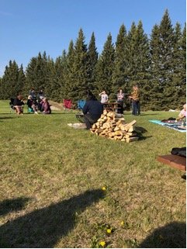
Special Thanks
The planning committee would like to thank Ron from Life’s Journey Inc. for being the LAEO Gathering fire keeper, and the students and staff from Winnipeg School Division who participated in this year’s gathering and taught everyone about FASD.
Introductions
Once the sharing circle was completed, everyone moved inside the Dining Hall to enjoy breakfast and begin making connections with other Gathering participants.
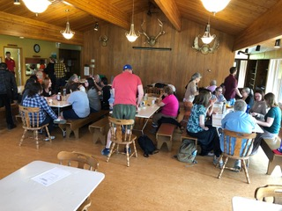
After breakfast the Emcees for the Gathering, Twyla Gilroy (South Parkland FASD Coalition) and Rodney Jones (Brandon & Area FASD Committee Inc.), welcomed everyone and acknowledged that we were honoured to host the Gathering on Treaty 2 lands, the traditional territory of the Ojibway and Dakota people and to recognize the Oji-Cree, Cree, Dene and Métis people of Manitoba.
Next, Rodney gave a brief overview of the LAEO project: a six to ten year project to promote dignity for all the individuals, women, families and communities impacted by FASD in Manitoba. Rodney explained that the LAEO project is now in its sixth year and encouraged participants to learn more about the project by visiting the LAEO section of the Manitoba FASD Coalition’s website: http://www.fasdcoalition.ca/looking-after-each-other-project/
As in previous years, participants were encouraged to build relationships with others at the gathering and to learn whom else in their communities they can work with to help their program participants understand and learn more about their culture. Rodney and Twyla then explained the primary focus for this year’s gathering is FASD: to learn from each other about the different ways we support people impacted by FASD and to learn about FASD through first-hand stories from children and adults with FASD.
Rodney and Twyla thanked all of the organizations who provided support in order to make the Gathering happen. The Manitoba FASD Coalition Inc. for providing a large portion of funding for the Gathering and University of Manitoba researchers who provided a generous contribution from the Social Sciences and Humanities Research Council (SSHRC) Grant. As well as all of the organizations and individuals that donated gifts for giveaways, volunteered their time to help out with various activities and all the little details to make the event a wonderful two days.
Finally, Twyla and Rodney explained that after breakfast people would have the option to participate in one of two very exciting opportunities: visit the Medicine Eagle Camp, or stay at Camp Wannakumbac to participate in a Tipi Teaching.

Visit to Medicine Eagle Camp
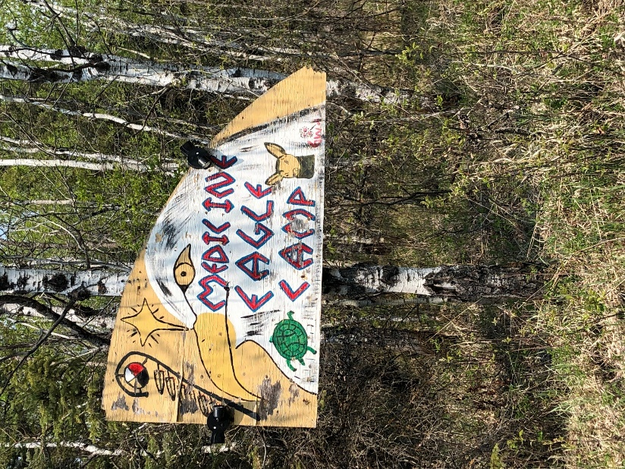
Elders Stella Blackbird and Audrey Bone invited gathering participants to visit their medicine camp named Medicine Eagle Camp, which is located near Camp Wannakumbac in Keeseekoowenin Ojibway First Nation.
After a short drive, Gathering participants arrived at the camp and had some time to look around before everyone was called to the fire to listen to Stella and Audrey talk about the camp.
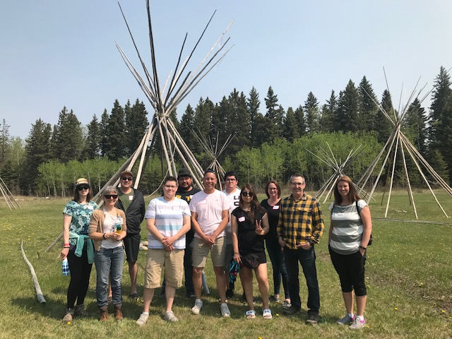
They shared the history of their camp and how they have worked with Parks Canada towards reconciliation. They shared stories about the different types of medicines that they pick at the camp and their healing properties. They explained how they are able to run the camp with the help of many volunteers who come to visit and stay at the camp over the spring, summer and fall. They have had people come from as far as South America and Europe to visit their camp and help them pick medicines.
Stella and Audrey also explained that they often have organizations bring youth to the camp to stay at the camp for several days to participate in land based teachings and help pick medicines.

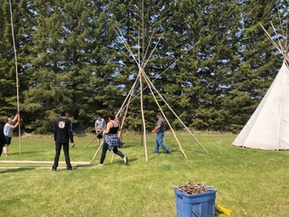
Tipi Teaching
Elder Frank Tacan led participants through a Tipi Teaching on the grounds of Camp Wannakumbac near the Sacred Fire. Frank brought four tipis to the Gathering and taught Gathering participants how to set them up. The group had time to set up three of the four tipis in the morning. The fourth tipi was set up in the afternoon. Raising the tipis was precision work embodied with specific meaning with all of the physical components of the tipi as well as the process.
Afternoon
After Lunch, participants had the opportunity to learn more about FASD by listening to two presentations from people with FASD:
FASD Classroom Students
Students and staff from the FASD classrooms at David Livingstone School in Winnipeg School Division were invited to attend day one of the gathering. The students had the opportunity to participate in the morning activities at Camp Wannakumbac and then present to everyone at the start of the afternoon. Due to the hot weather in the afternoon, everyone gathered inside the Dining Hall to listen to the students teach about the brain domains associated with FASD and how the brain domains impact learning at school.
Each student had a turn to speak about one brain domain. They explained what the domain is responsible for within the brain, their areas of strength and the challenges they have within that brain domain and the strategies they use to accommodate those challenges (see Appendix A for two examples of student presentations).
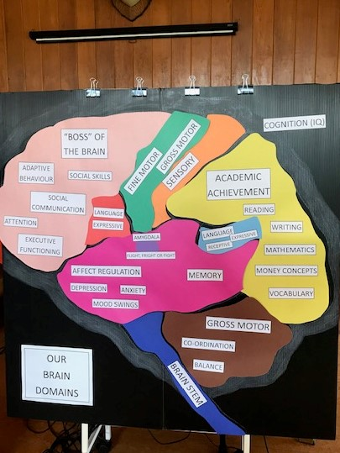
The students also had a visual of the brain that they used during their presentation to help people learn about the areas of the brain responsible for each domain. As each student talked about a brain domain, another student would place the brain domain onto the visual. By the end of their presentation, each part of the brain was placed onto the visual. The visual was left out on display for the remainder of the gathering for participants to look at and learn more about how students with FASD learn best in school.
After their presentation, the students handed out copies of the book Living and Learning with FASD: Jilly’s Story, which was written by students in the FASD classrooms at David Livingstone School. Jilly’s Story is about a girl named Jilly who speaks openly and honestly about what it is like to have FASD. She speaks about her struggles, but more importantly, her successes in order to help people develop a better understanding of FASD. The students were excited to announce that they are currently working on a sequel to Jilly’s Story that shares her experiences as a junior high student. The hope is that the book will be ready for the fall of 2019.
Visions and Voices Presentation
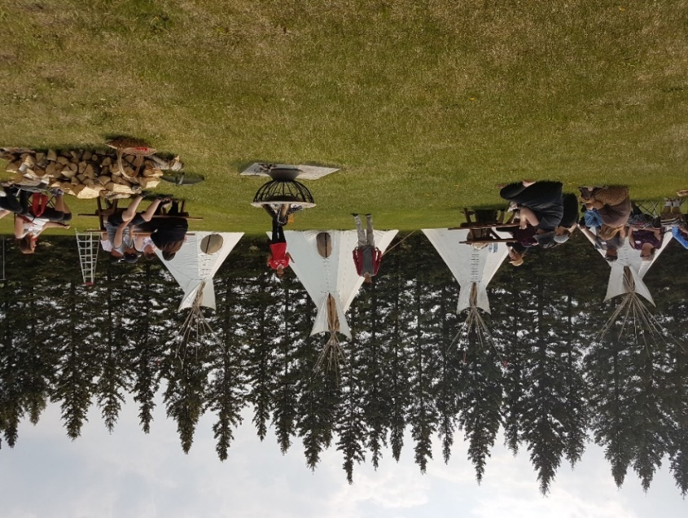
After the students finished their presentation, everyone moved back outside to sit around the Sacred Fire and listen to a presentation from two members of the Visions and Voices Program, Jessica Siddle and Russ Hilsher. The Visions and Voices Program offers presentations led by people with FASD. Presenters share their stories of hope, struggle and accomplishment in order to increase FASD awareness, understanding and promote dignity for those impacted by FASD.
Russ and Jessica spoke to the group and shared their stories in order to teach people about FASD. They shared stories about what works best for them, what does not work well and the strategies they use to accommodate for those challenges. They each took turns answering questions such as:
- Their experiences in school: what went well/did not go well, what did teachers do that helped?
- Their friendships/relationships with others: how do they make friends, how do they know if someone is a “good” or “bad” friend?
- Support workers: what do you like about your support workers, what are some of the things that support workers do that you do not like?
- Happiness/belonging: at the end of the day what makes you happy, where do you feel you belong?
Russ and Jessica then took some time to answer questions from the audience before ending their presentation. Twyla and Rodney then thanked Russ and Jessica for sharing their stories with everyone and reminded everyone that the Visions and Voices Program is available to present in communities across Manitoba.
Stations
For the final portion of day one, people had the opportunity to be in charge of their own learning. Several stations were set up around the grounds of Camp Wannakumbac. Some were outside close to the Sacred Fire and others were set up inside the tipis or the Dining Hall.
- Baby Moccasin Sewing – a table was set up inside the Dining Hall with supplies to help participants sew baby moccasins. Elder Roseanna Desjarlais from Ebb & Flow provided a moccasin teaching and assisted people with their baby moccasins. People took the baby moccasins they made home with them. They could also take copies of the instructions home so they can teach others in their communities how to make baby moccasins.
- Story Sticks – Elders Debbie Cielen and Mary Maytwayashing set up a station where people could make their own story sticks. Participants decorated their story sticks with symbols that represent important elements or events in their lives, as a way to help them tell their life story.
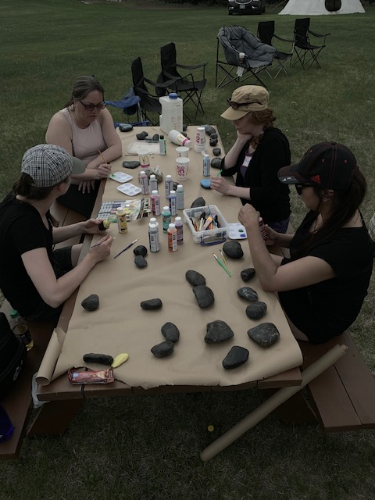
- Rock Painting – a station was set up on one of the picnic tables near the Sacred Fire where people could paint Grandmother and Grandfather rocks and talk with other gathering participants.

- Medicine Pouch Making – Deborah Tacan set up a medicine pouch making station inside one of the tipis by the Sacred Fire. Deborah invited people to come inside the tipi to talk with her and learn how to make their own medicine pouch.

- FASD Resource Table – a resource table was set up inside the dining hall. People were invited to look at the resources available and were encouraged to ask questions in order to learn more about FASD and how to support people impacted by FASD.

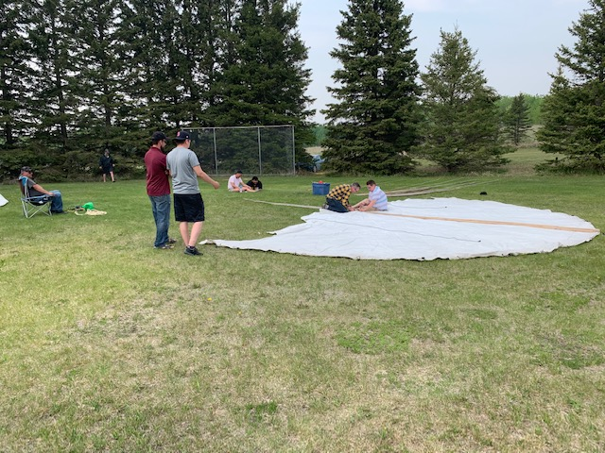
- Tipi Teaching – Elder Frank Tacan provided one more Tipi Teaching to gathering participants. Many of the people who participated in the morning tipi teaching took the lead on setting up the final tipi. Gathering participants were happy to apply what they had learned in the morning and Elder Frank Tacan was there to provide guidance whenever the group needed some assistance.

- Skirt Teaching – Carol Moar set up a station inside one of the tipis by the Sacred Fire. Gathering participants were invited to come inside the tipi to talk with Carol and listen to different grandmother Teachings.

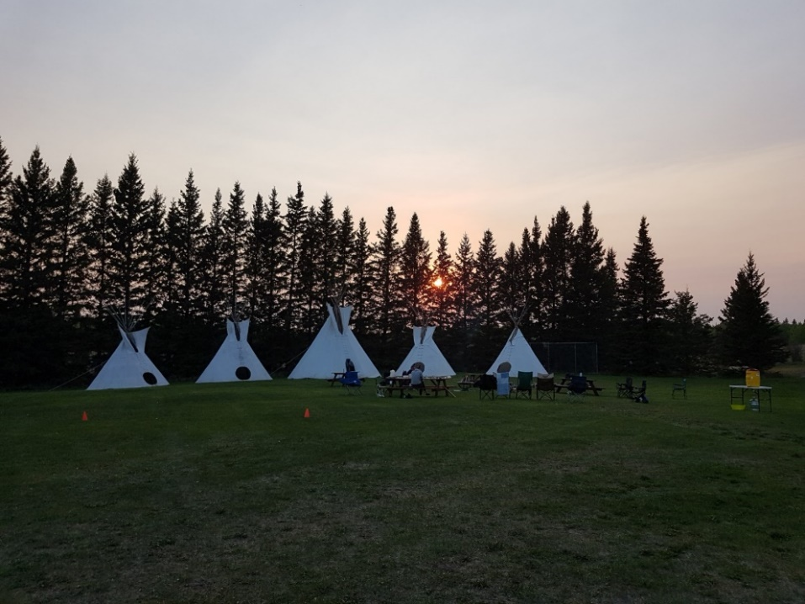
Evening
After dinner, people were given free time for the remainder of the evening to choose what they wanted to do. Some people chose to rest after an eventful day, others chose to drive into Wasagaming to explore the town and see the beach. Others chose to stay outside on the land to sit by the sacred fire where they had the chance to connect with other Gathering participants and get to know each other on a more personal level.
A special thanks to Ron and Sean from Life’s Journey and Rodney Jones for keeping the Sacred Fire burning overnight.
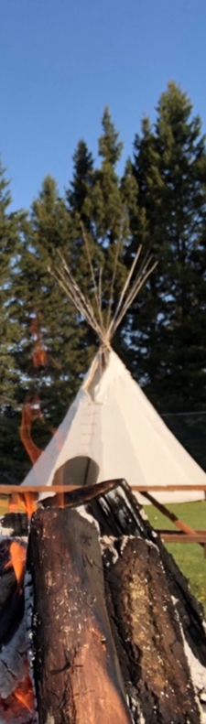
May 30 – Day 2 of the LAEO Gathering
Everyone who stayed overnight at Camp Wannakumbac woke up early and began getting ready for another exciting day of presentations and discussions. People made their way to the Sacred Fire to discuss what they had done the previous evening and to wait for everyone to arrive.
A heat warning was issued on day two of the Gathering, so a decision was made to move all of the activities inside. Everyone made their way from the Sacred Fire inside to the Dining Hall to eat breakfast and await the morning teachings.
Another special thanks to Ron for going outside at different times throughout the morning to take care of the Sacred Fire.
Medicine Teachings
To begin the morning, Elder Stella Blackbird and Elder Audrey Bone provided a Medicine Teaching. They began their Teaching by playing two videos.
The first video, titled Sharing Our Histories: The Keeseekowewin Ojibway, shared the history of the Keeseekowewin Ojibway First Nation and the area’s ecology. The video can be found on the Parks Canada website: www.pc.gc.ca/en/pn-np/mb/riding/decouvrir-discover/autochtones-indigenous/video/communiquer-sharing
The second video, titled Makwa Mee Nuun, shares the story of three generations of Anishinabe medicine women (Stella Blackbird, Audrey Bone and America Hotain) who pick medicines inside Riding Mountain National Park and actively work towards reconciliation with Parks Canada. The video can be found on the National Screen Institute’s website: www.nsi-canada.ca/2013/07/makwa-mee-nuun/
After watching the videos, Stella and Audrey continued their Medicine Teaching. They discussed the different types of medicines they pick, their healing properties and the ways in which each medicine can help people.
After Stella and Audrey finished their Teaching, everyone was invited to come up to the front to see the different medicines that they brought to the Gathering. People were very excited to take a closer look at the medicines and ask questions about them. People also had the opportunity to take some of the medicines home with them.
Before lunch, some of the stations from day one were set up inside the Dining Hall and outside by the Sacred Fire. People were given the option to either participate in the stations that were set up, or to explore the grounds of Camp Wannakumbac with other gathering participants. Some people chose to take a walk around the camp and others went down to the lake to be near the water on this very hot day.
Sharing Circle
After lunch, everyone moved inside the Pavilion to take part in a Sharing Circle. The Sharing Circle provided everyone with one last opportunity to share their thoughts and feelings about the two day event.
Many people expressed thanks for being invited to the event and for the opportunity to meet and/or reconnect with so many caring people. Several people took this opportunity to thank all of the people with FASD who attended the Gathering for sharing their stories and teachings throughout the two days.
Closing and Farewell Prayer
After everyone had a chance to share, Twyla thanked everyone for participating in the two-day event. Elder Debbie Cielen then led a farewell prayer to thank everyone for participating in the 2019 LAEO Gathering and to wish everyone safe travels on their journey home.
Appendix A: Brain Domain Presentations
Presentation #1 – Academic Achievement
Hi, I am in grade 7. One of my strengths is that I am a fairly strong reader and do well at paper and pencil tasks.
The Brain Domain that I am talking about is Academic Achievement. This is the brain domain that helps me with my learning at school.
Strengths:
Most of the time my classroom is really quiet but sometimes the hallway can be very distracting. When this happens I go and close the door and let my teacher know that it is really noisy in the hallway and she will go and talk to the students that are disrupting us. Another strength I have is that when I am struggling with my school work I almost always ask an adult for help.
Challenges:
When a classroom is loud I get really distracted and I have difficulty focussing on what the teacher is teaching. I also have a lot of difficulty remembering how to spell words, how to do easy math facts and I really struggle with understanding money concepts. I tend to rush when I do my work, which causes me to get really frustrated because I make a lot of mistakes and then I have to redo my work.
Strategies:
When I was younger and the room or hallway was too noisy, I would wear ear protectors, which would help to block out the noise. I have now learned to close the classroom door and if I need I will ask to work in a quiet spot. When I have difficulty remembering how to spell words, I have learned how to use a dictionary or with adult help we sound the word out together and I try my best to get it correct. It also helps me when my teacher reminds me to slow down and gives me extra time to complete my work. When I need something to help me focus, I will ask for a mint!

Presentation #2 – Sensory Processing
Hello, I am in grade 7. Some of my strengths are that I am good at basketball, enjoying having conversations with adults and like helping others.
The Brain Domain that I am talking about is Sensory. This is the part of the brain that controls how well I can focus at school and at home and stay on task when doing school work.
My strength is that I know that I need a rocking chair to help me focus, especially when I start to get anxious and I am starting to understand how important it is to have a good sleep every night.
Challenges: I tend to get easily distracted in class, especially if other students are talking or when someone is making noise by tapping their pencil or talking to themselves and even if someone is wearing strong perfume. If I have to sit for too long I start paying less attention to what is being taught.
When I was younger and I needed to settle my brain, I would use fidget toys or ask to go to the bunny hole. Now that I am older, I use a rocking chair to help me settle or I ask my teacher for a glass of water, which gives me a movement break. I have also learned to politely ask my classmates to please stop making noise which I know also helps other students with their learning.

